Company description
H.Y Bank is a comprehensive bank offering a wide range of services. Clients could open different kinds of accounts here and choose a variety of banking business like financial management, securities investment and funds business. H.Y bank has experienced business managers who can provide clients with safe and secure financial services, and effectively assist customer management their accounts and businesses they chose to achieve investment returns.
Business rules
1.Each client may have many accounts at least one account, but each account belongs to only one client.
2.Each manager may serve many clients, but each client must choose only one business manager.
3.Each account must be managed by only one manager, but one manager may manage many accounts.
4.Each account must correspond to only one business, and each business may be selected by many accounts.
5.Each client could choose many businesses and each business could be selected by many clients.
6.Each manager could handle with many businesses and each business could be managed by many managers.

ERD Diagram
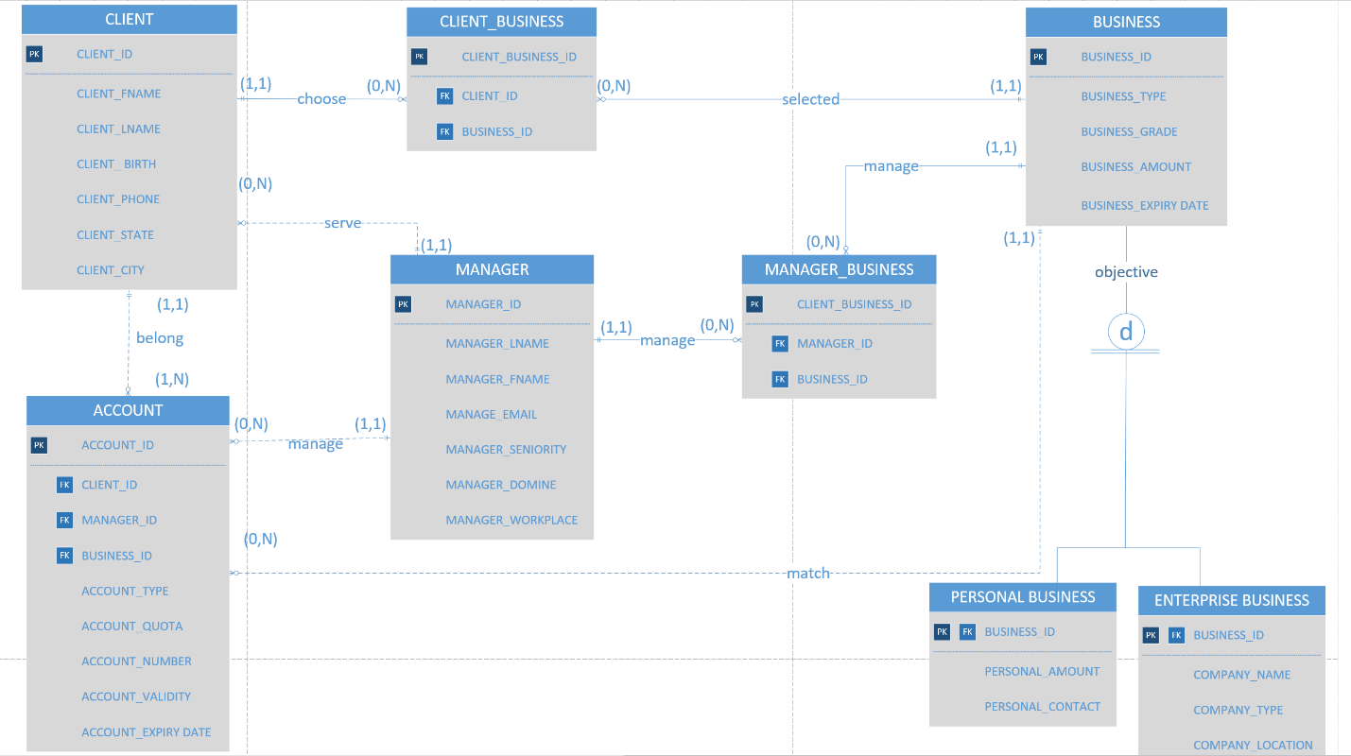

Create CLENT table.
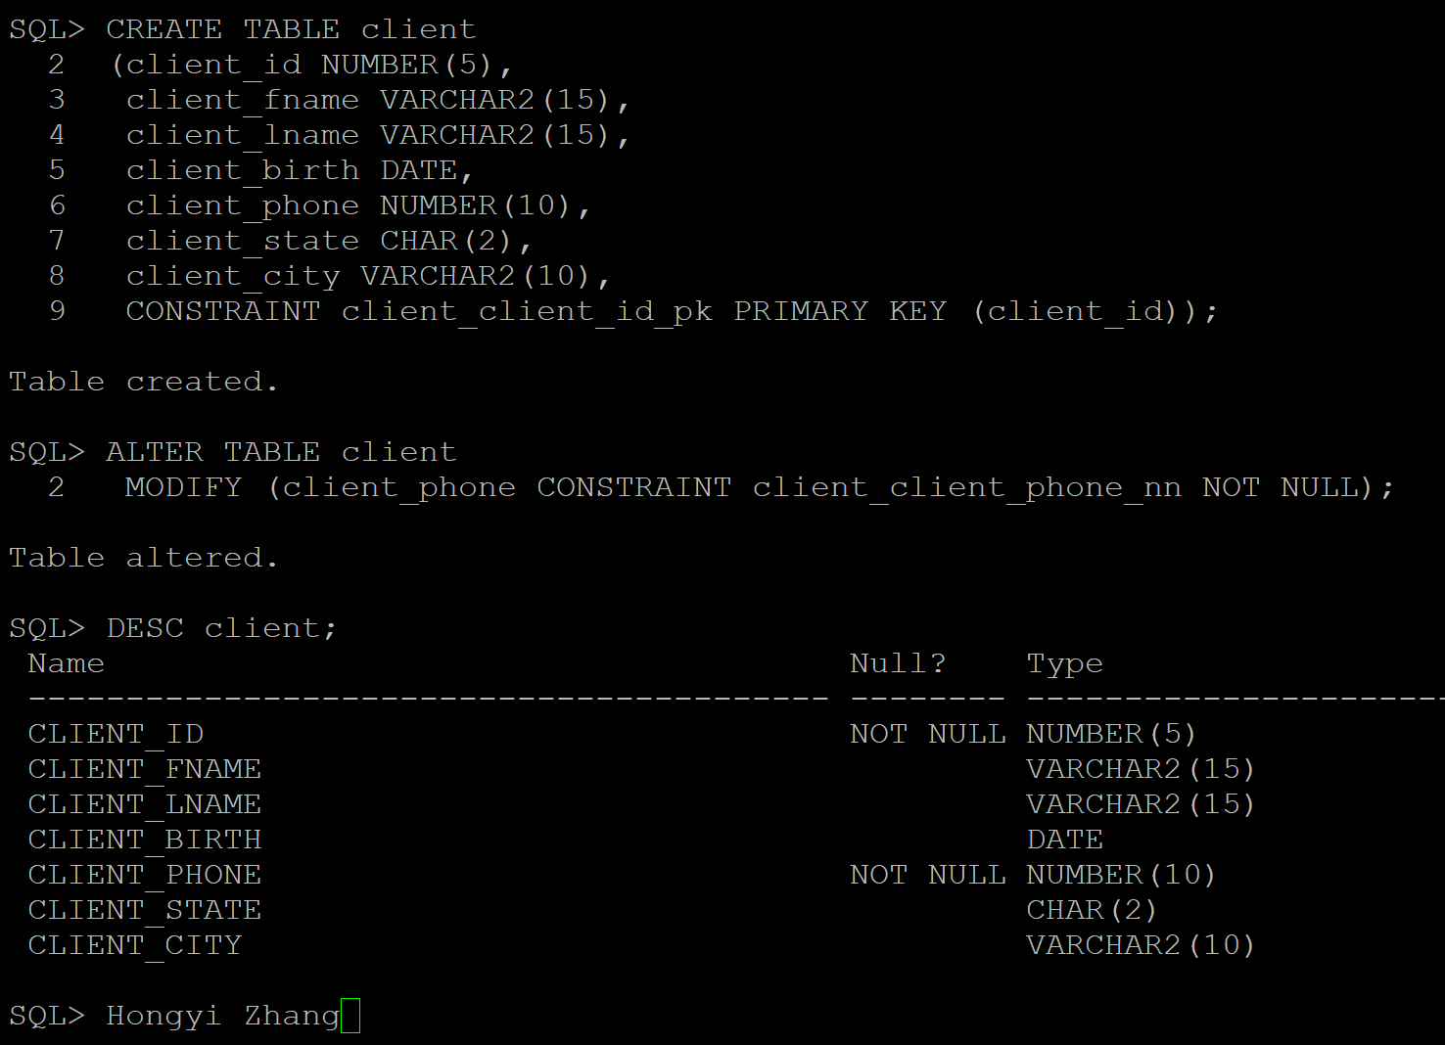
Insert records into CLIENT table.
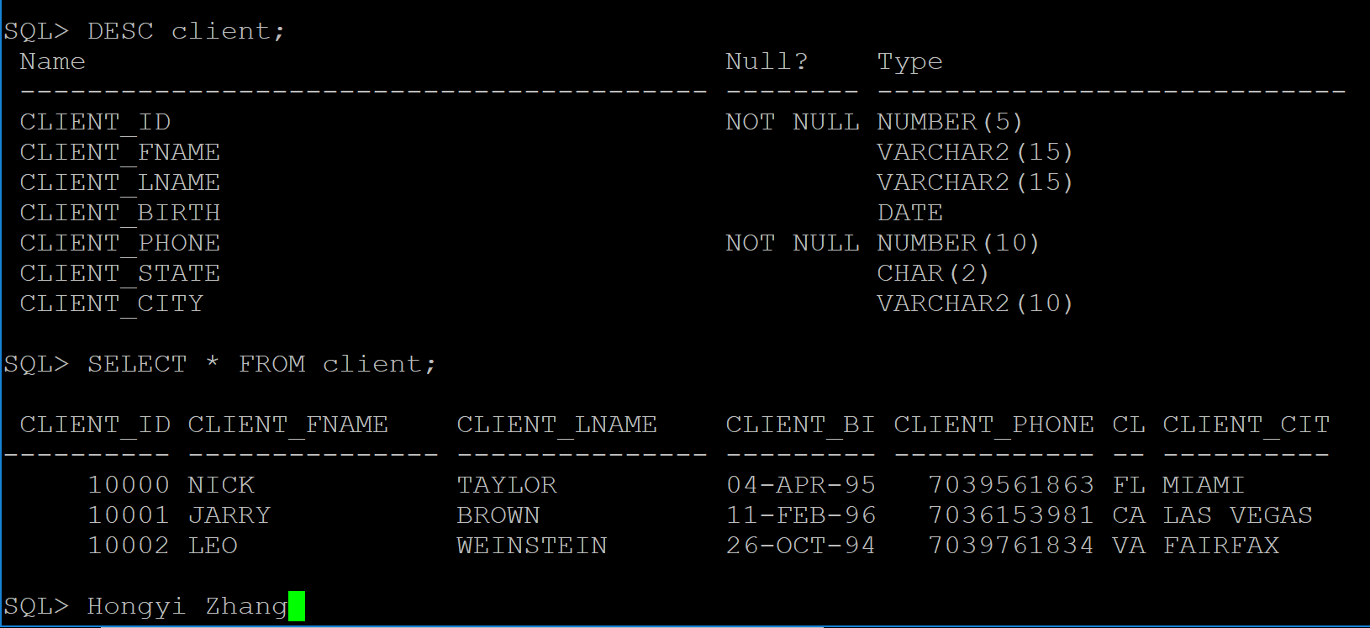

Modify data of tables
JOIN commands:
- Write a SQL code to join two tables using the WHERE statement. Explain what the query is intended to do.
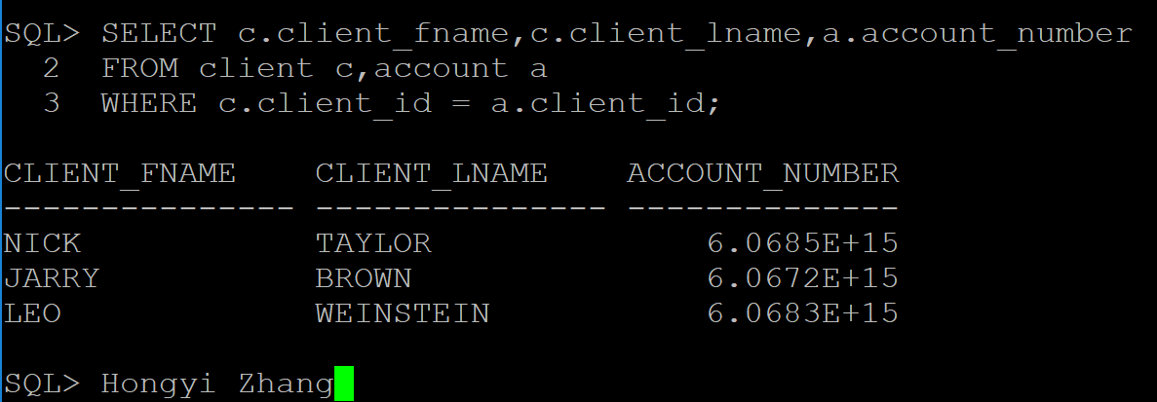
Explanation:
The SQL intended to get name of client and account number by taking c.client_id = a.client_id as a condition to join client table and account table using WHERE statement.

- Repeat problem 1 using the JOIN … USING keywords.
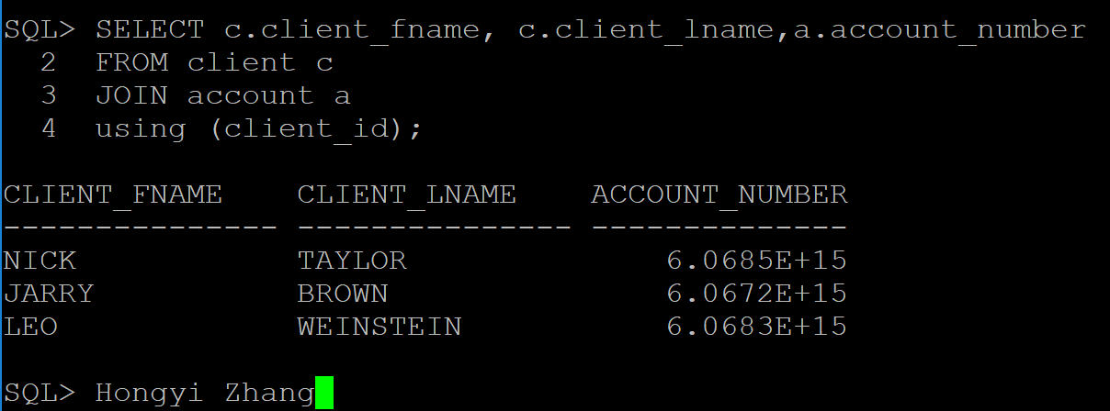
Explanation:
The SQL intended to get name of client and account number by taking client_id as a condition to join client table and account table using JOIN…USING keywords.

- Repeat problem 1 using the JOIN … ON keyword
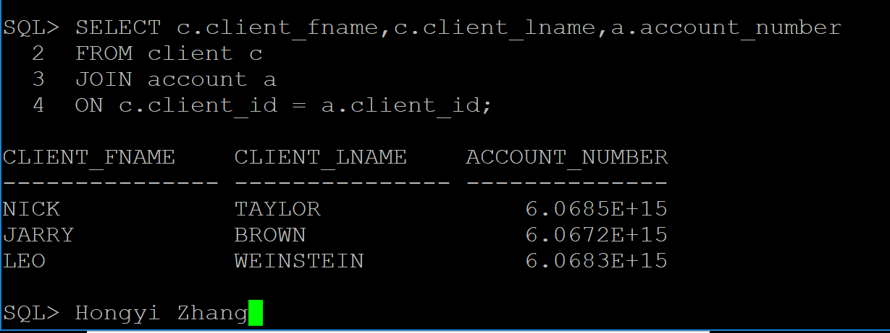
Explanation:
The SQL intended to get name of client and account number by taking c.client_id = a.client_id as a condition to join client table and account table using JOIN…ON keywords.

Single-row:
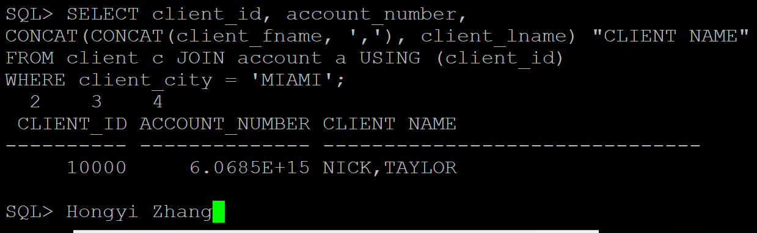
Explanation: This SQL intended to retrieve client id, account number and client’s name that displayed as a single string ‘First name, Last name’ who live in Miami.

Group commands:
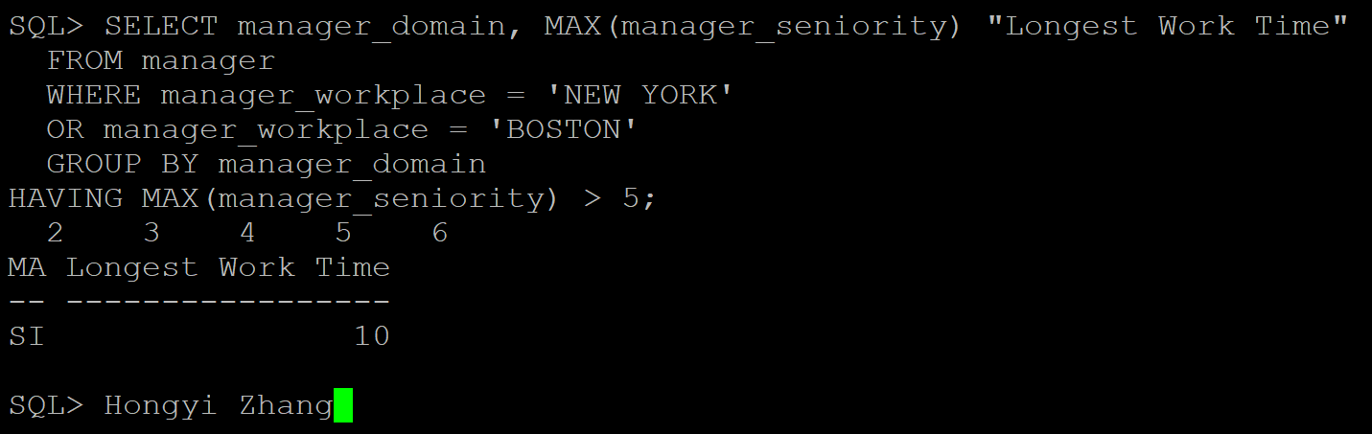
Explanation: This SQL intended to retrieve manager domain and their average work time of each domain whose work place is New York or Boston and working time more than five years.
Subquery:
Determine which orders were shipped to the same state as order 1014. Tip: Use a single-row subquery in a WHERE clause.
